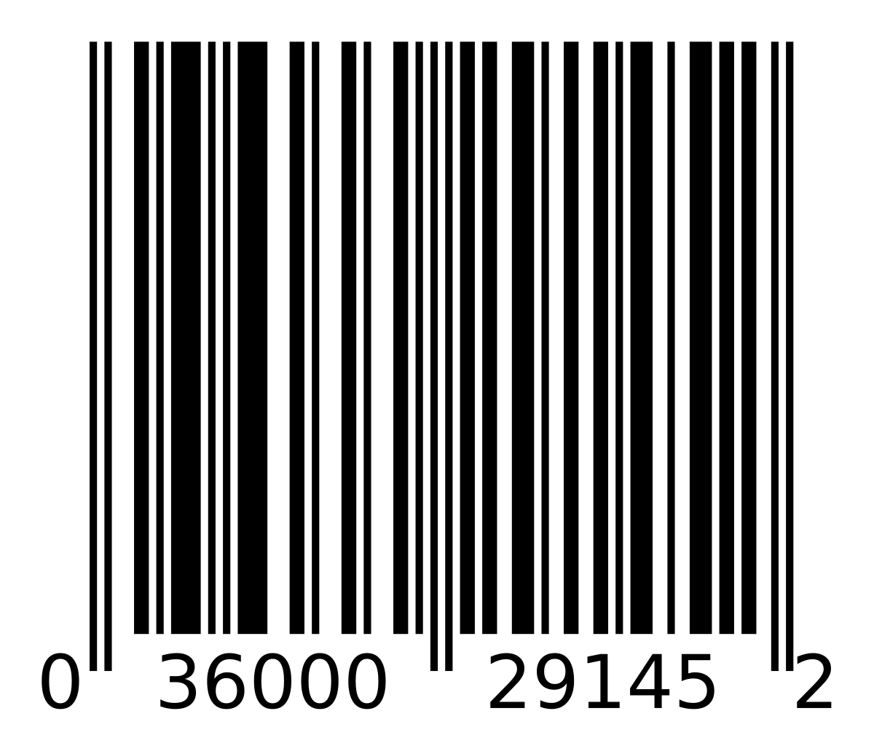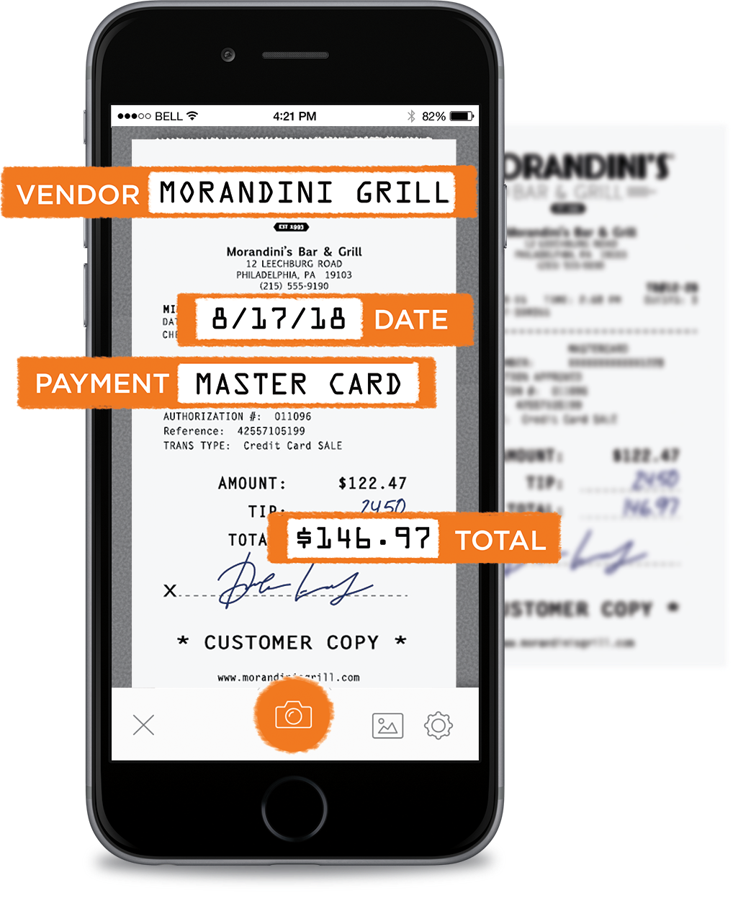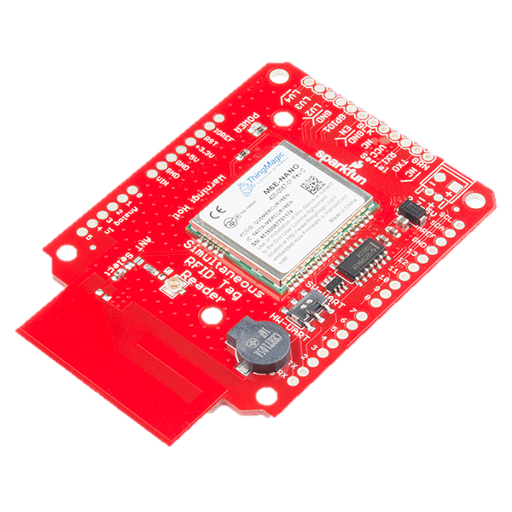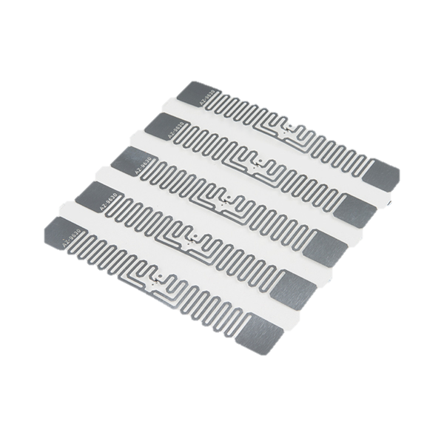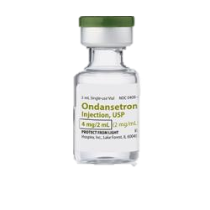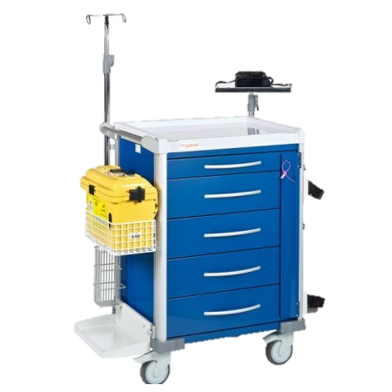

bluboxrfid@gmail.com

**Financials**

**Future application**

**Contact**

Sales ($ Thousands)

10000

Units (1% of market)

3000

Units

500

Units

100

Units

40

Units

Hospitals, Logistic Hubs, anti-theft systems

**Competition**

**Speed**

**Cost-effectiveness**

**Army camps**

**$22,000**

**Singapore healthcare> $1 million**

**All logistical hubs island wide**

* Quick
* Superior value compared to similar technology
* Convenient
* Automated

**Benefits**

**Market Size**

**Store/verify  
on digital database**

**Read/write data**

**Optically   
read data**

Medic notes drug details

Medic records it down

**Blubox**

* Smartphone optical reader + Simultaneous RFID reader
* One click to scan entire trolley
* Digital database

Problem: Managing inventory of medical items in the resuscitation trolley is a **tedious**, **time consuming** and **error prone** process.

**Product**

ERROR

ERROR

**Problem**

**Technology**

* Optical reading
* Long range RFID

**Solution**

With BluBox a medic can now check an entire resuscitation trolley in a few seconds and with just a few clicks, with absolutely no  
room for errors.

**BluBox**